**INTRODUCTION**

The following document describes the requirements and the user guide for successfully interacting with the dashboard. It is divided into two parts:

1) Requirements

1) User guide

1. **REQUIREMENTS**

**MAC**

The dashboard executes Python scripts to forecast the time series, for this reason it is requires a TabPy (<https://tableau.github.io/TabPy/>).

1. Install TabPy if you have not already done it (included in requirements.txt)

pip install tabpy-server

1. Navigate to the source code contained of the TabPy installation in /site-packages and go subsequently into the tabpy-server directory. In our case: python3.7/site-packages/tabpy_server
2. Execute sh startup.sh or python tabpy.py to start up a server, and don’t close the terminal.
3. Now, on Tableau, set it to sniff port 9004
   1. Go to Help → Settings and Performance → Manage External Service Connection
   2. Select Tabpy, and enter the Server (localhost if running TabPy on the same computer) and the Port (default is 9004).

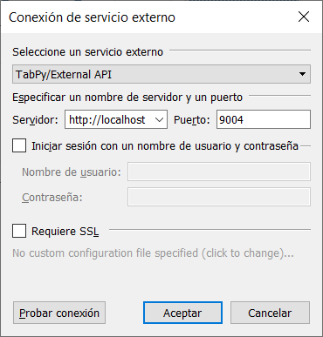

1. End. Tableau should now be able to execute python scripts.

**WINDOWS**

The dashboard executes Python scripts to forecast the time series, for this reason it is requires a TabPy (<https://tableau.github.io/TabPy/>).

1. Open the Conda Prompt as an administrator and run “conda install -c anaconda tabpy-server “, and click “y” to proceed with the installation
2. Go to the directory where the configuration files are installed: it is either:

*“cd C:\Users\*your_user*\Anaconda3\pkgs\tabpy-server-0.2-py37_1\Lib\site-packages\tabpy_server”*

or

*“cd C:\Users\*your_user*\.conda\pkgs\tabpy-server-0.2-py37_1\Lib\site-packages\tabpy_server”*

1. Execute startup.bat on the Conda Prompt.

**WARNING: if an error with an .asyncronous method arises, downgrade your Tornado package to 5.1.1.**

Now you should have the web service running on port 9004.

1. So, on Tableau, set it to sniff port 9004
   1. Go to Help → Settings and Performance → Manage External Service Connection
   2. Enter the Server (localhost if running TabPy on the same computer) and the Port (default is 9004).

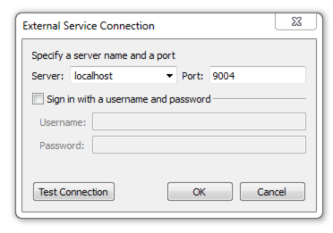

When loading the file in Tableau, the following pop-up window will appear:

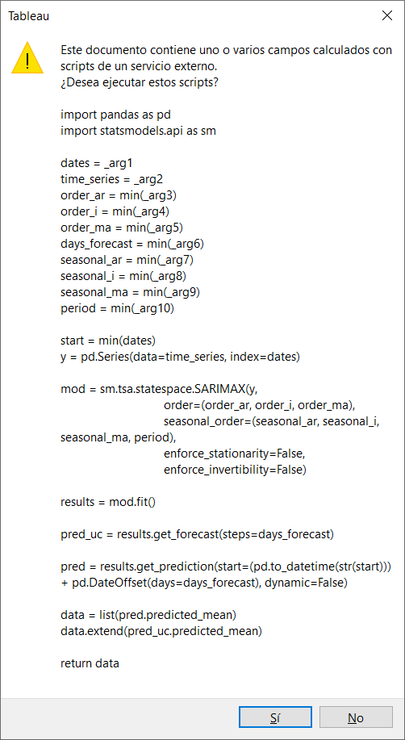

It is needed that the user agrees to execute the script for the forecasts to be calculated.

**NOTE:** it is strongly recommended to be patient as the script is being executed. Some minutes might pass before the script finishes its execution. Once it has finished, the charts will display. When selecting any filter in the charts, as values will be recalculated, the user will have to wait again for about 10 to 20 seconds:

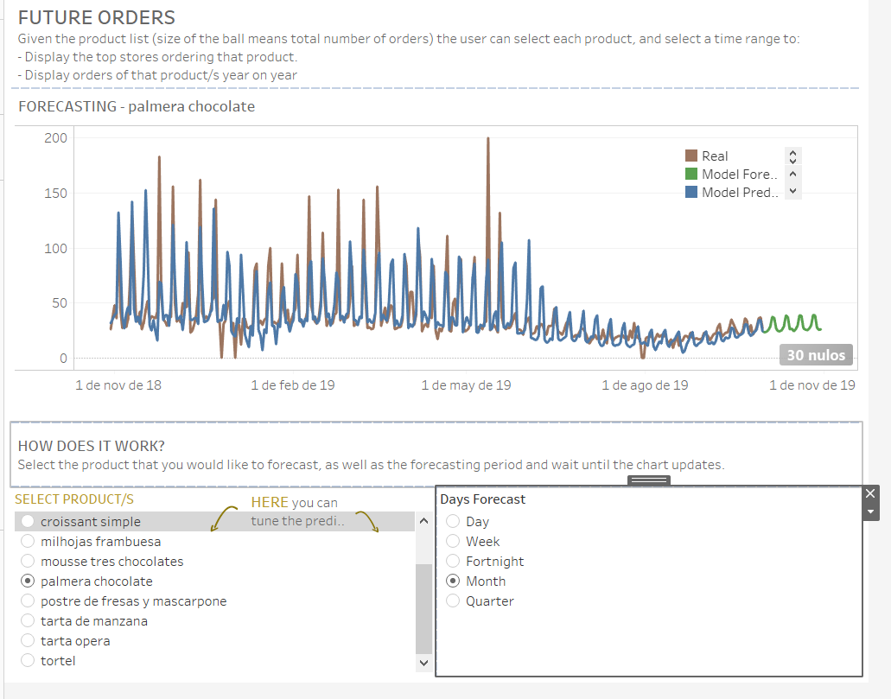

1. **USER GUIDE**

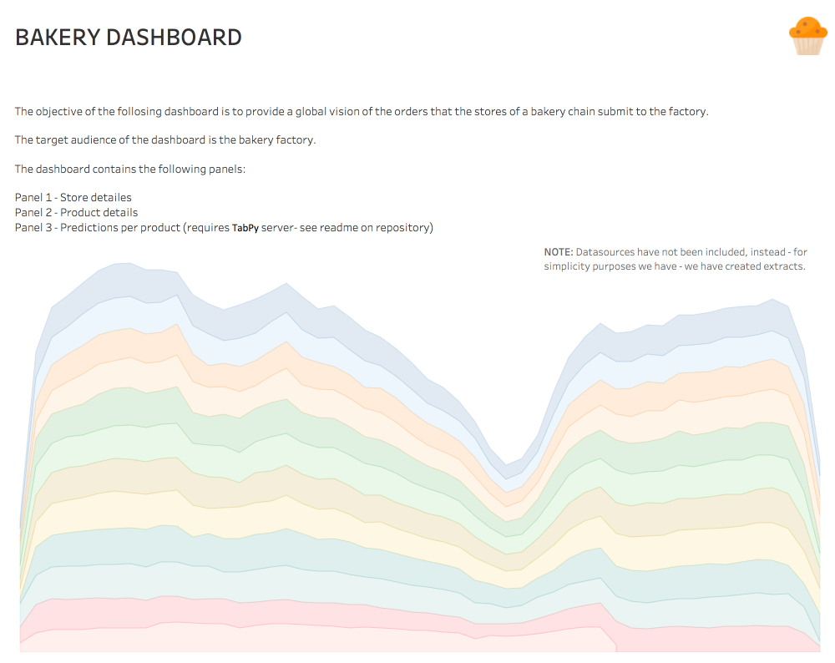

**PANEL 0 – Introduction**

Describes the objective of the dashboard and lists the panels.

**PANEL 1 – Store Details**

Describes the objective of the dashboard and lists the panels.

Chart 1: Map

Chart 2:

Chart 3:

**How to Interact?**

By clicking on each store on Chart 1 you select the store

By selecting de date-range o the top right corener.

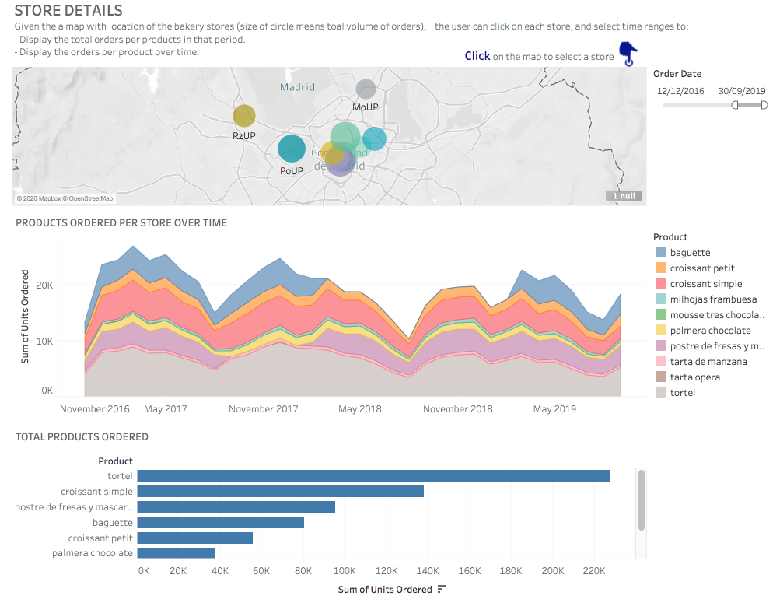

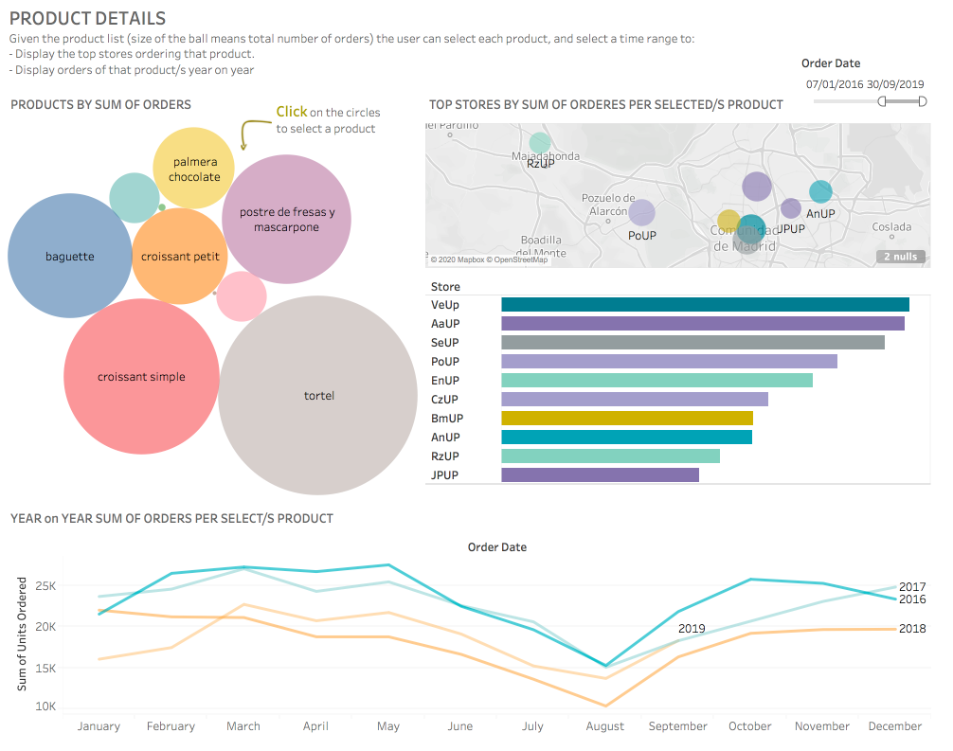

**PANEL 2 – Product Details**

Describes the objective of the dashboard and lists the panels.

Chart 1: Circels

Chart 2: Map

Chart 3: Bar-chart

Chart 4

**How to interact?**

By clicking on each store on Chart 1 you select the store

By selecting de date-range o the top right corner

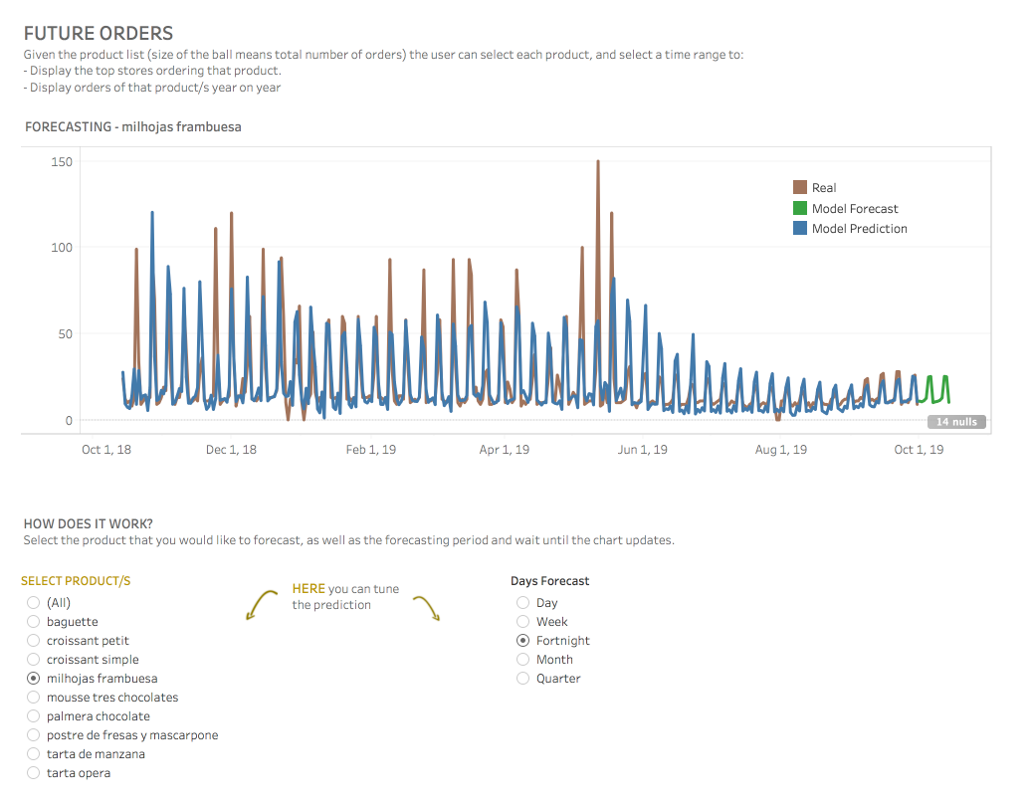

**PANEL 3 – Forecasting**

Describes the objective of the dashboard and lists the panels.

Chart 1: Map

**How to interact?**

By selecting the Product/s and the timeframe to predict at the bottom.



**PANEL 3 – Forecasting**

Describes the objective of the dashboard and lists the panels.

Chart 1: Map

**How to interact?**

By selecting the Product/s and the timeframe to predict at the bottom.